***Payrate Program***

***Created by Channon Harper***

***S3871491***

[***S3871491@student.rmit.edu.au***](mailto:S3871491@student.rmit.edu.au)

**Program Start**

When the program is first started a terms and condition box will open from here the user can select “**true**” or **false**. Only entering **true** will allow the program to run any other input will be false and the program will close.

Once the program has started the user will be asked to select how many staff records, they wish to enter. The value must be of **positive number** as well as **numerical.**

**Main Program**

This is the main program as you can see has 3 windows  
Window 1 – a console window, it is a window to display text output to the user it will show any errors that occur as well as any edits that are made.

Window 2 – the main selection window with input fields  
 a – will add a record to window 3 table from textfield ‘h’  
 b – will edit first name from selection in table from textfield ‘i’  
 c – will edit last name from selection in table from textfield ‘i’  
 d – will edit hourly rate from selection in table from textfield ‘i’  
 e – will edit hours from selection in table from textfield  
 f – will display info of creator and version of GTerm used   
 g – will shut all open windows  
 h – is a text field for user entry to add records **must use commas** between inputs  
 i – is a text field for user entry to edit depending on selection

Window 3 – the table window displays a table and the ability to remove  
 a – the table itself with all the headers will populate with entries  
 b – will remove an entry from the selection of the user  
***Note*** that in the table you will see extra headings with normal pay overtime total, there will also be another line once an entry has been made with a running total of all totals. These are auto calculated from the entries and **cannot be edited**.  
**Inputs***First Name* – Will return an initial so can be a single character **must be alphabetical**   
*Last Name* – Can be anything the user wishes however **cannot contain be blank or contain any Spaces**  
*Hourly Rate* – can be anything between the range of **16 and 199 must be numerical**  
*Hours* – can be anything between the range **0 and 112 must be numerical and a whole number**

**Adding a record**

To add a record the user will enter the data for the staff member in the textfield, from there they will press the ‘add record from text’ button. If the entries are valid the table will populate with the data.

If there was an invalid input at any area the console window will show the error and why it was incorrect. From there the user will be prompted for a re-entry if the re-entry is invalid will ask again until a valid input is received.

**Editing a Record**

The edit record works the same for any of the inputs you wish to edit. As you can see in the example user will select the record from the table enter the new value depending on what they wish to edit then press the corresponding button.

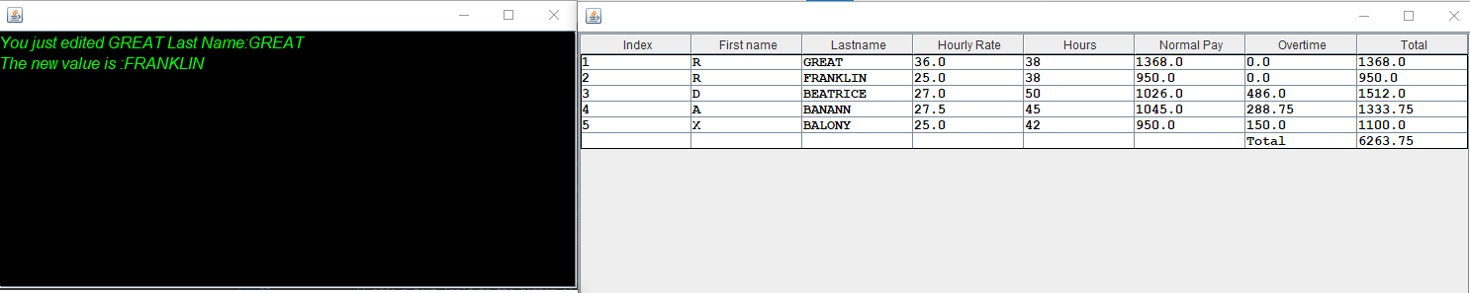If the entry was valid will change the value in the table as well as show the user in the console what they edited and the new value of it.

However, if the input in the text field is not a valid entry it will display what the user was trying to edit show an error message and keep the initial value prior to the attempt of editing.

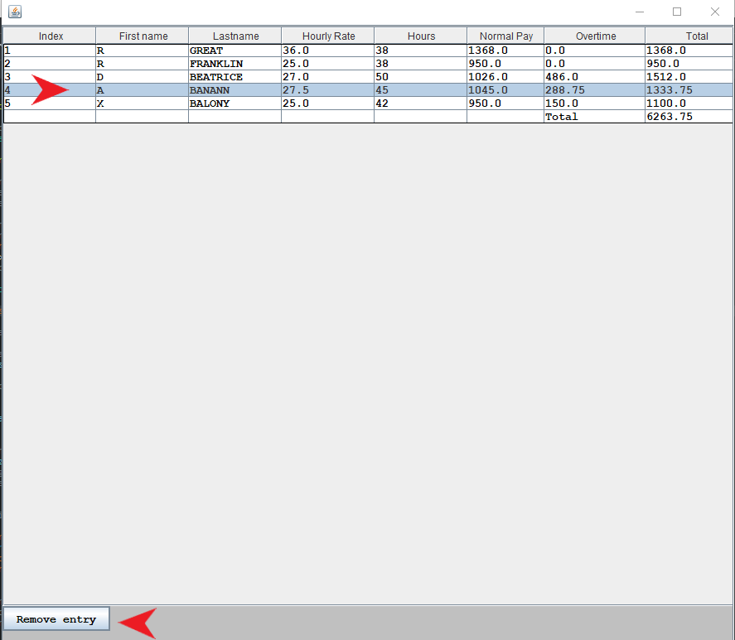**Removing a Record**

To delete a record the user is to select a user from the table and simply click the remove entry button.

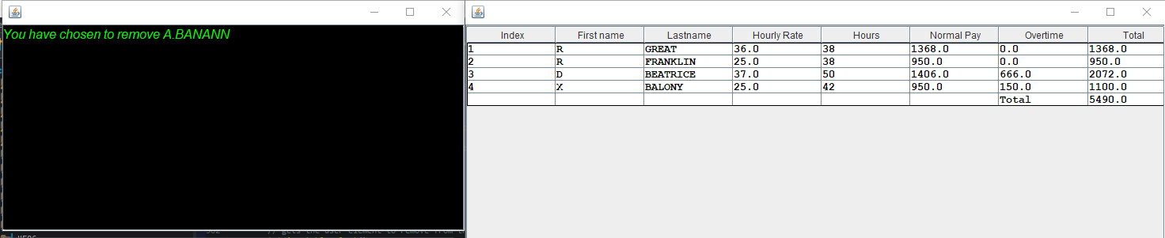Once the button has been pressed user will see the user, they deleted in console window and the table will refresh to show the removal.